575. BRUNSSUM 7,4km
www.wandelgidszuidlimburg.com

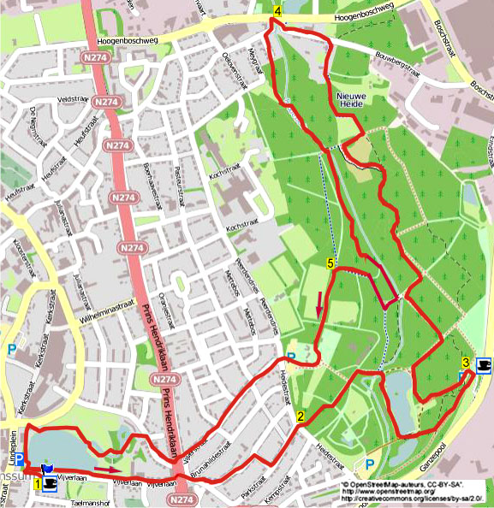

During this flat and leisurely walk from the beautiful Vijverpark to the nature park Schutterspark, you are walking along a beautiful wooden path in the nature park Hangvennen. The way back is a nice walk along the river Roode Beek. At the end you walk through the beautiful Vijverpark. There are sufficient seats.

Starting point: Hotel Edenpark, Vijverlaan 10 Brunnsum.
You can park your car on the Lindeplein, for your navigator: Lindeplein 3
.

Gps distance: 7400m
Duration: 1.40
Height: 39m

Left = L
Right = R
Straight ahead = ST

www.wandelgidszuidlimburg.com

575. BRUNSSUM 7,4km

1. With your back facing the hotel, cross the road to the pond and go L on the sidewalk. After 50m, go R down the stone stairs and go R along the pond. At the end of the pond, go R up the stone stairs and then go L on the sidewalk into the Vijverlaan. Ignore side roads and walk straight up to the main traffic lights. Cross ST the priority road, go ST and immediately take the first road diagonally R. Ignore byways right and then we walk ST through the Schutterstraat along housenr. 1. Go past housenr. 34 R the cobbled road. At the T-junction with the Parkstraat L. Ignore side roads and walk up to the T-junction with the Heidestraat.

2. Cross the road and go ST down the forest path. Walk ST exactly along a fallen tree. On the unequal crossing with green marking, go ST. At the junction with seats, go ST on the paved path (green / orange / blue). After 30m, go R down the way to the pond. Walk ST over the bridge and immediately jump to the R along the pond. Go L at the end of the pond at the T-junction. After 100m, go ST between the thick trunks. Walk exactly ST through the forest up to a gangway. Go L here, and immediately go R. Follow the path up to the top of the T-junction at the Bare Foot Park with a coffeeshop. Go L here into an open meadow.

3. Go L through the meadow and go ST down the long wooden stairs (green). Go ST down to the pond and then R on the asphalt. At the end of the pond, go R into the small road at the 3-jump with seats. Ignore the path immediately on the left and go L after 200m down into the first country road (green, blue). At the T-junction at the bridge, go R. At the junction with seat, go L towards Hangvennen (red / blue). At the 3-jump, go ST up along a picnic bench (blue). Follow the path along the beautiful nature until the sign with Forest and Nature, go L here on the wooden path. At the end arriving at the T-junction, go R on the paved path. When arriving at a seat, take the first paved path L (blue). Ignore a country road on the right and walk right up to the T-junction with a paved road, and go L there.

4. Walk to the priority road and go L on the sidewalk across the bridge. Immediately after the bridge, go L onto the bike path. The road bends to the right and immediately take the first turn L along housenr. 3. At the end, go ST through the narrow passage and follow the forest path (blue). At the intersection of narrow paths, go ST. You arrive on a lawn, go L here. At the end of the lawn, go L on a narrow path to the river (So not the blue route). Go R directly at the river, and then keep following the river Roode Beek. At the concrete bridge, continue ST along the river. Keep walking along the stream. You will pass a concrete bunker and stay close to the river. Walk up to the concrete bridge and turn R into the forest (green). Keep left in the woods, and you will come to a T-junction. Go R here (yellow). At the next T-junction, go L (yellow).

5. At the T-junction with seat, go L on the paved path along the sporters pitch. Ignore a forestpath on your right. Ignore the paths on the left side and keep following the paved road around the Schuttershuuske. You will arrive at a large parking. Cross the parking diagonally to the right, go ST on to the sidewalk that goes up. Walk up, cross the asphalt road and go ST through the Vijverstraat. Ignore all side roads and pass housenr. 2. Then go R down the stone steps. Carefully cross the main road, and go ST down the asphalt road (zone 30). Opposite housenr. 49, go L onto the paved footpath. At the T-junction in front of the pond, go L. Go R onto the wooden bridge and immediately go L. Take the second bridge with the stone walls on your left. After passing the bridge, go immediately R along the pond. Pass the wooden bridge and immediately turn L. Walk around the pond and take the stone stairs in the right corner. Go L back to the hotel. You are welcome here for a cup of coffee or a delicious Belgian beer. There is also a garden terrace. (Saturday and Sundayafternoon closed).

Auteur: Jos Wlazlo

Het Auteursrecht van deze tekst en het Databankenrecht op deze route ligt volledig bij de auteur. Niets van deze wandelroute mag worden gekopieerd, verveelvoudigd of openbaar gemaakt zonder toestemming van de auteur.

